Name:  Teacher : | ____________________________________  ______________________ | Due  Date:_________
 | Year 7  Statistics Data Report  Message in a Bottle - How Far Does Water Travel?
Total Time: | 2 lessons in class – 1 week to complete
Weighting: | 12%
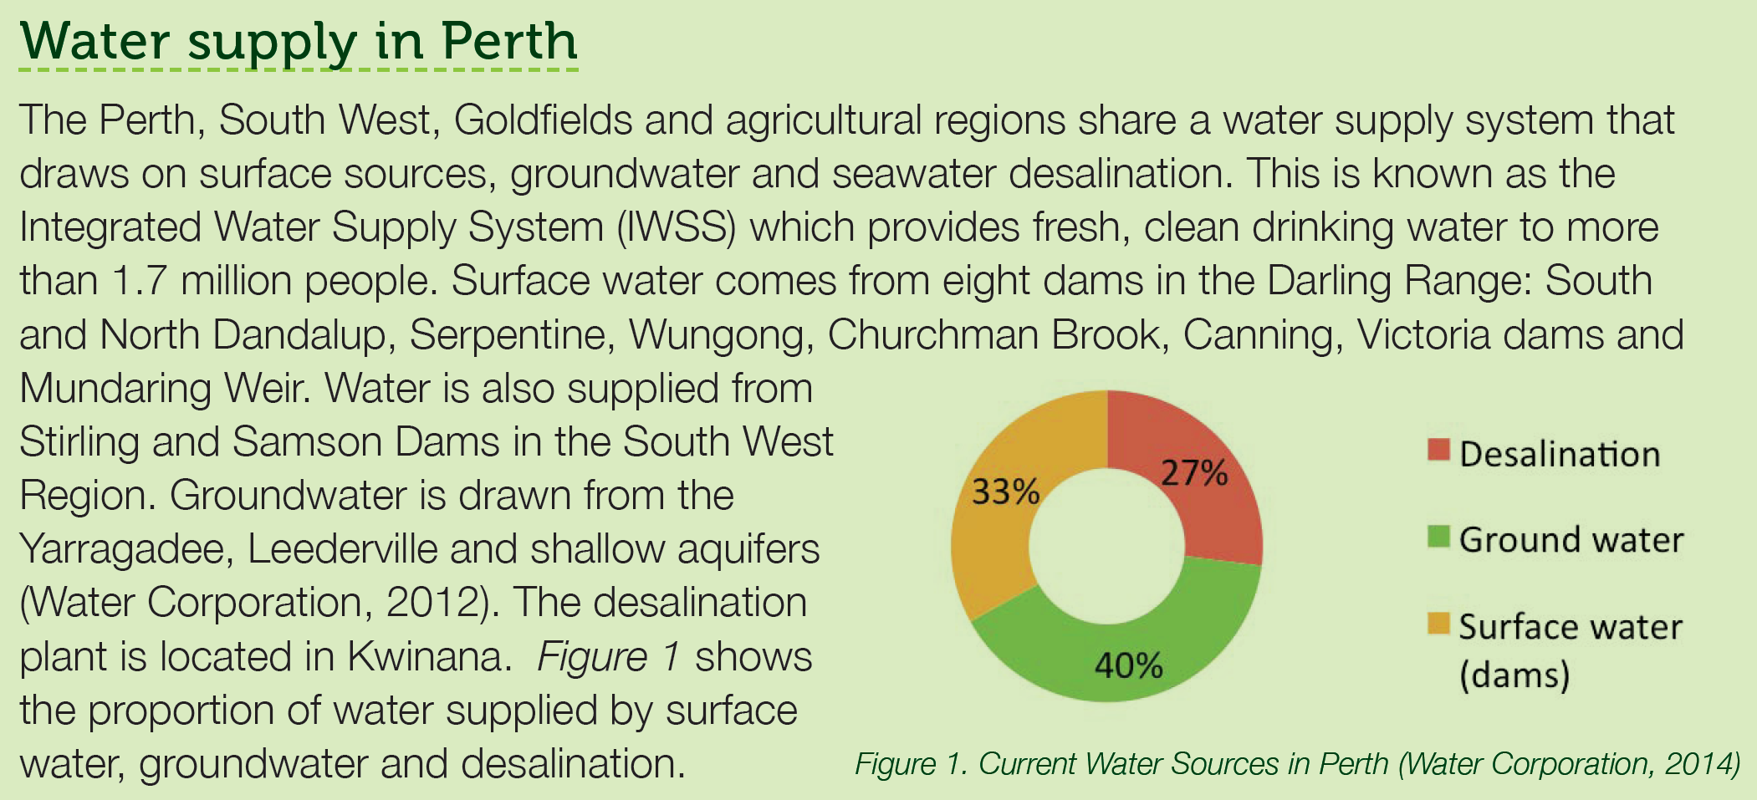
Table 1: Distance travelled from local water sources to Perth.
Location of Water Source | Distance travelled to Perth Homes (km)
North Dandalup Dam | 99.2
South Dandalup Dam | 112
Serpentine Dam | 88.7
Wungong Dam | 51.5
Churchman Brook Dam | 49.9
Canning Dam | 28.2
Victoria Dam | 28.2
Mundaring Weir | 55
Yarragadee Aquifer | 33.3
Leederville Aquifer | 11.8

Table 2: Distance travelled by bottled water to Perth.
Bottled Water Brand | Bottling Location | Distance travelled to Perth (km)
Fiji | Yaqura, Fiji | 6385
Aqua Pure | Salisbury, Sa | 2689
Mount Franklin | Kewdale, Perth | 22.2
Evian | Evian-Les-Bains, France | 14239
Thank You Water | Mt Tamborine | 4353
Frantelle | Welshpool, Perth | 24.5
Snowy Mountain | Daylesford, Victoria | 3353
Woolworths Select | Gingin, WA | 76.9
Pump | Kewdale, Perth | 22.2
Yaru | Mount Warning, NSW | 4360
Coolrdige | Welshpool, Perth | 24.5
Pureau | Sydney, NSW | 3948
Waiwera | Auckland, NZ | 5343

Your task is to create an informative statistics report based on the data provided answering the question: How Far Does Water Travel?
Introduction
What is the question? | This question asks about…  This means I will need to create a ______________ table and a _______________. So that we can see the information easily.
What data/information have I been given?

How do you think this data was collected?

What graph could I use for this information?

Data Analysis
Put numbers into order  MMMR  Frequency Table  Graph | Choose appropriate class widths for frequency tables  Create frequency tables on Excel  Create column graphs from frequency table on Excel  Make sure to include a title and axis labels  Either save table and graphs as images or save Excel document and email
   | Local water sources distance | Bottled water distance
  Mean
  Median
  Mode
  Range
Interpret and explain:  What does this mean?  Local water sources | The mean is ________. This is large/small which means…  The median is _______. This means that…  Was there a mode?  The mode is _________.  This means that…  The range is _________. This is large/small which means…  The graph visually showed…
Bottled water sources | The mean is ________. This is large/small which means…  The median is _______. This means that…  Was there a mode?  The mode is _________.  This means that…  The range is _________. This is large/small which means…  The graph visually showed…

Conclusion
Conclusion | Our question from the top is:  What was the answer to the question from the information and graph?
How could I ask another question or improve on information from this report? | Now that we know the answer, is there another question(s) we can ask?  Could we use this information to help develop water sustainability practices?  What do you predict will happen to this data if we asked the same question in 10 years time?

The final report must include the tables and graphs from Excel. The report can be typed or handwritten, and does not have to use the sentence starters.

